In addition to the maths tasks we always give the children a reasoning activity (Twist It) and a problem solving (Solve It) each day. Please have a go if you have time.

**Year 2 Monday**

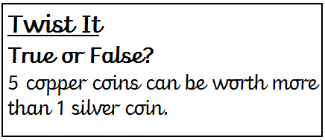 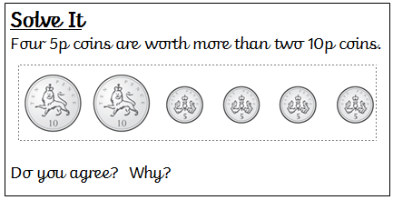

**Solve It**

If the time is 20 to 10 what number would the minute hand be on?

If the time is 10 past 4 what number would the minute hand be on?

**Year 2 Tuesday**

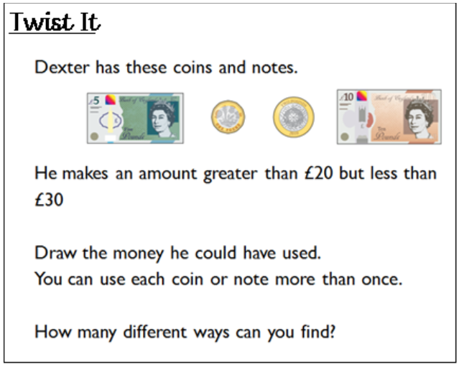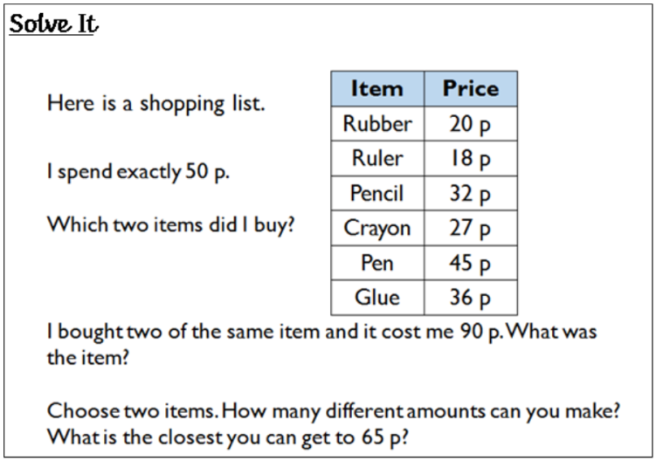

**Year 2 Wednesday**

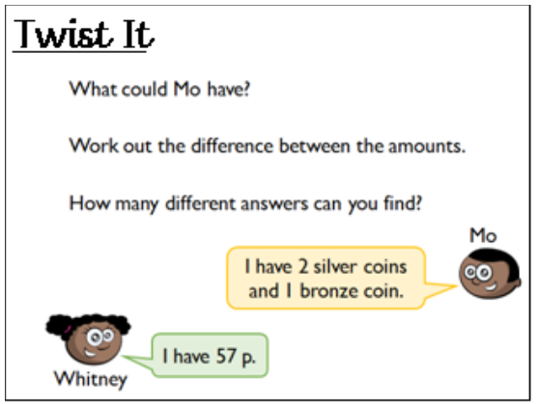 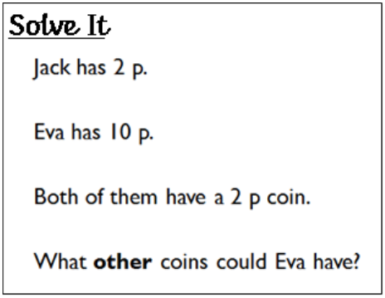

**Year 2 Thursday**

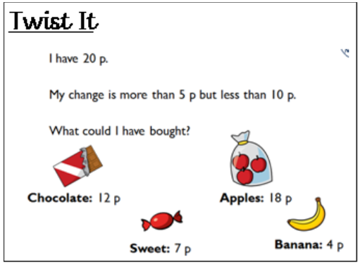 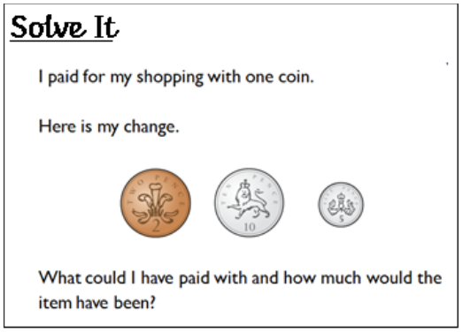

**Year 2 Friday**

