In addition to the maths tasks we always give the children a reasoning activity (Twist It) and a problem solving (Solve It ) each day. Please have a go if you have time.

Year 1 Monday
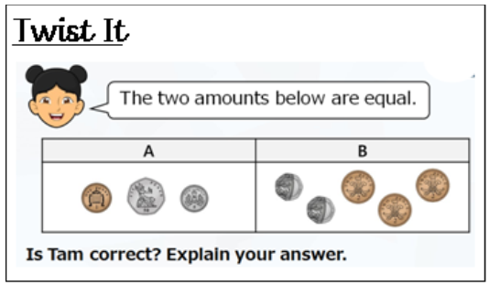
Solve It
There are 3 coins less than £1 that have an even value?
True or False?
Explain how you know.

Solve It
If the time is 20 to 10 what number would the minute hand be on?

If the time is 10 past 4 what number would the minute hand be on?

Year 1 Tuesday
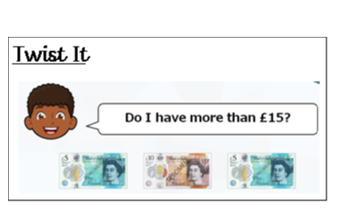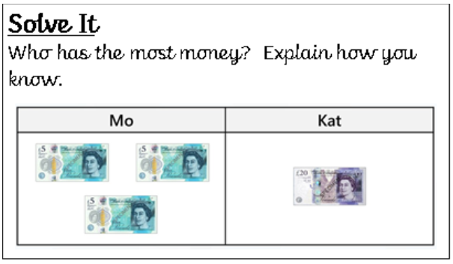
Year 1 Wednesday
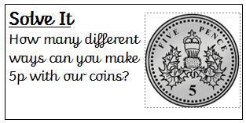

Year 1 Thursday
None for today – enjoy playing shops!

Year 1 Friday
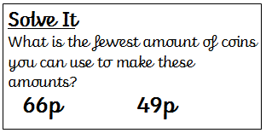
Twist It
Choose 3 coins. If you add their totals you always get an odd number?
True or False? Prove your answer!

